**Full Stack Development with MERN**

**Frontend Development Report**

|  |  |
| --- | --- |
| Date | 18 July 2024 |
| Team ID | SWTID1720077433 |
| Project Name | Grocery App |
| Maximum Marks |  |

**Project Title: All-Mart Grocery App**

Date: 19/07/2024

Prepared by: Mohammed Zaid, Naveen R, Mohammed Faisal

**Objective**

The objective of this report is to document the frontend development progress and key aspects of the user interface implementation for the All-Mart Grocery App project.

**Technologies Used**

* **Frontend Framework:** React.js
* **State Management:** Context APU
* **UI Framework/Libraries:** Bootstrap
* **API Libraries:** Stripe

**Project Structure**

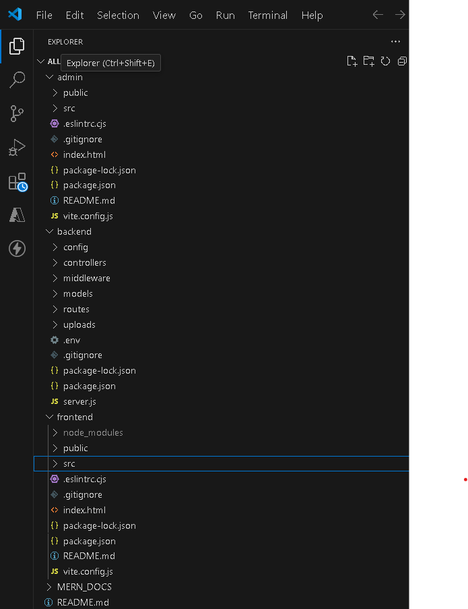

**Key Components**

1. **App.js**
   * Responsible for routing and main application layout.
2. **/components**
   * Contains reusable UI components used across the application.
3. **/pages**
   * Includes different pages for Web App.

**Routing**

Routing is managed using React Router. Here are the main routes:

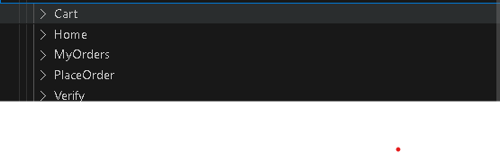

* **/cart** – Cart Page of Grocery App
* **/home** – Landing Page of App
* **/myOrders** – Retrieve Previous Orders

**State Management (If Applicable)**

State management is achieved using Context API

**Integration with Backend**

The frontend communicates with the backend APIs hosted on <http://localhost:4000> Key endpoints include:

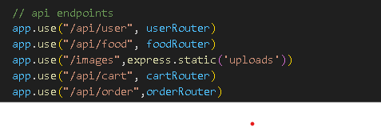

**User Interface (UI) Design**

* The UI design follows the design principles
* Implemented using Bootstrap.

**Third-Party Integrations (If any)**